This is a web application project with Angular 11 for UI , back-end - spring boot and cloud SQL - DB.

## **Start UI:**

* In order to start the project in your local, Please clone the code from the repo.
* Once it is cloned, go to the respective folder where your cloned project is.
* Go to the **angular-11-client** folder.

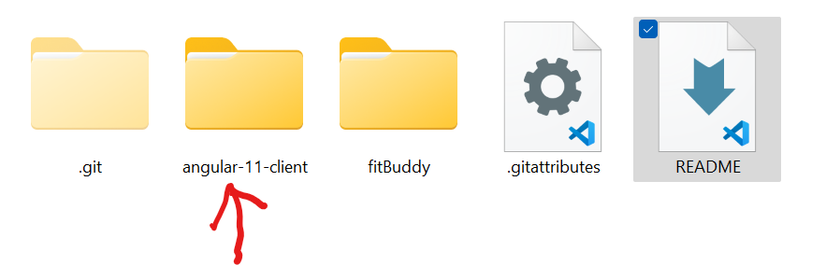

* Then open the command prompt inside the **angular-11-client**  and go **npm install-** just to be sure all the node modules are downloaded(I’ve already included all of them. This is just to be sure)
* Once it is done, do **ng serve** , to start the app.
* Then open localhost:[**http://localhost:4200/**](http://localhost:4200/)to see the UI app running.
* To see the code, make sure to open in any of them IDE that you have. I personally prefer visual studio code for this.

**Note: However, make sure you run the spring boot app before go to see the whole app up and running.**

## **Start Backend (Springboot app):**

* Now that you already have the cloned project, go to the fitBuddy folder.(This has the backend code)
* In order to run this, open, Spring Tool Suite or Eclipse. Please use this link to download STS - <https://spring.io/tools>
* Once you have it downloaded, open the app.
* Once you have the app opened, **click on File**.

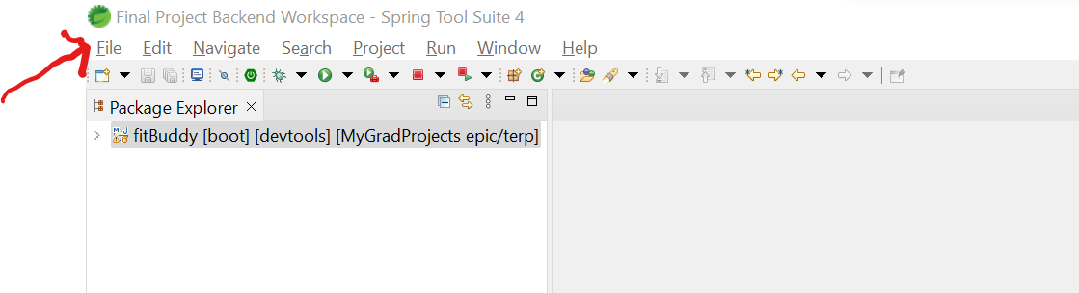

* Here click on **import**:

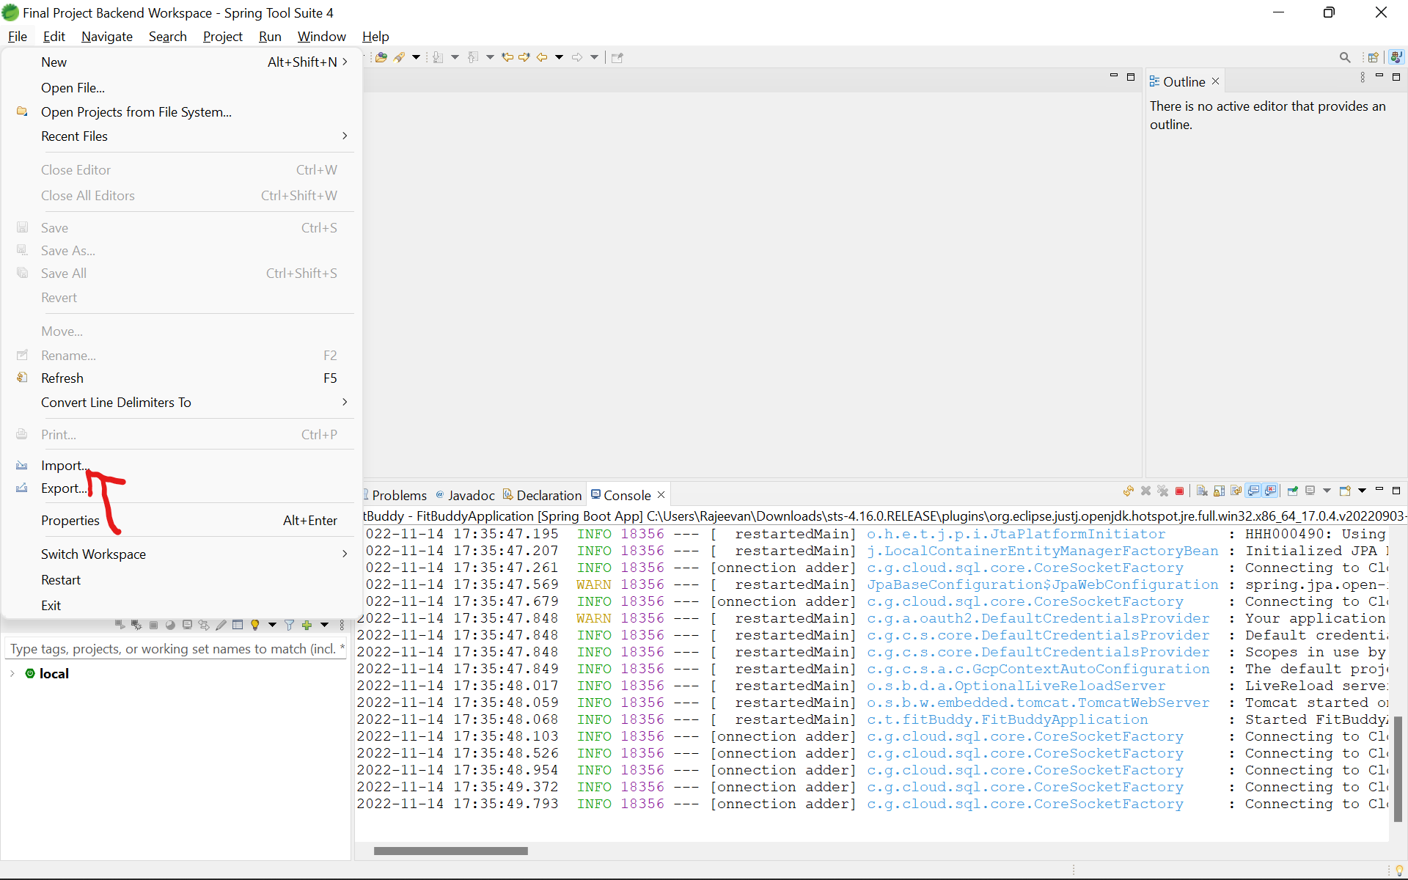

* A pop up like this will open and then click on **Maven> Existing Maven Project.**

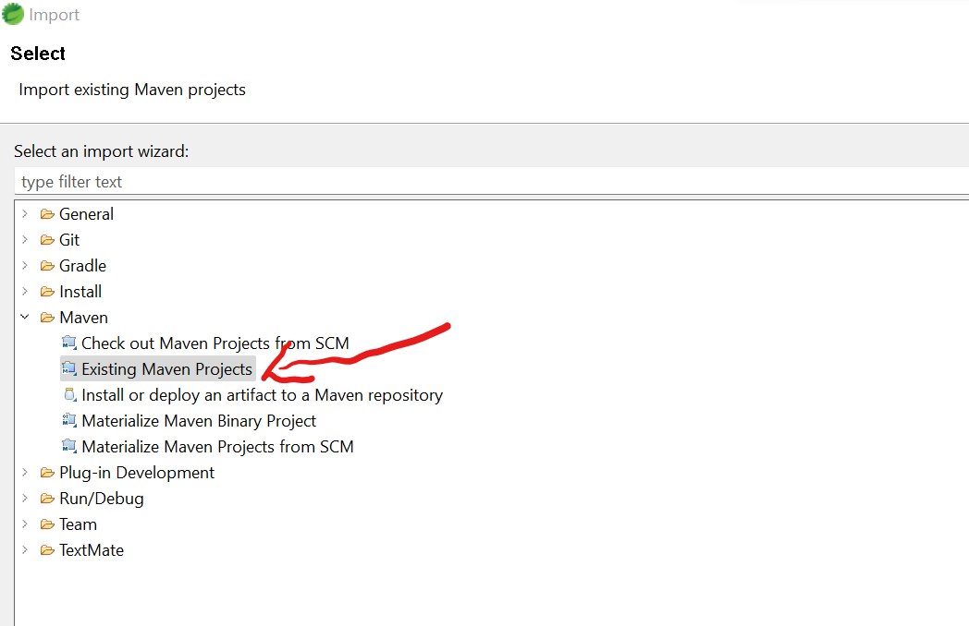

* Click **Next.**
* Click the Browse button and **open the fitBuddy folder from the cloned project**.
* You’ll see a **pom.xml** file here like this:

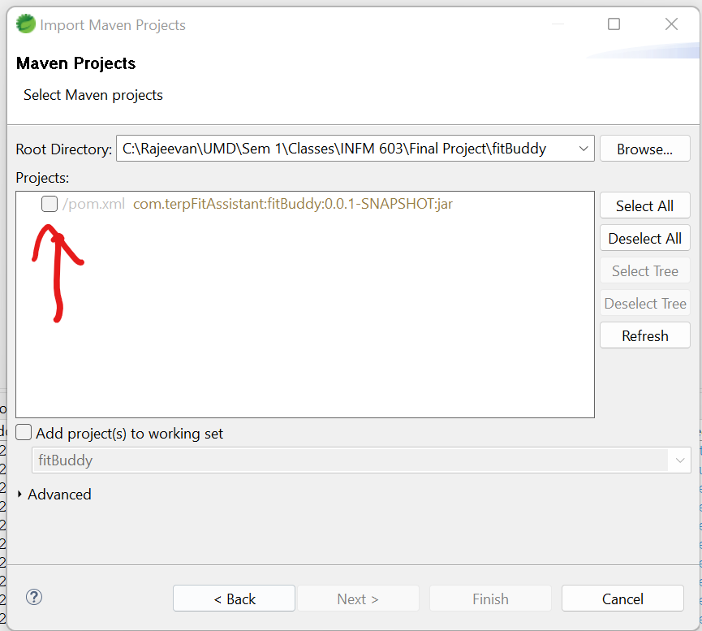

* **Select the box next to the pom.xml and click on finish**.
* In about 30 seconds, the project will be opened completely and you’ll see it in this format when you expand the project.

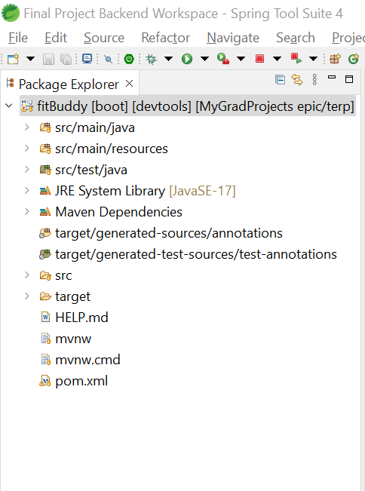

* Then right click on the fitBuddy ( whole project ) and you’ll see these options:

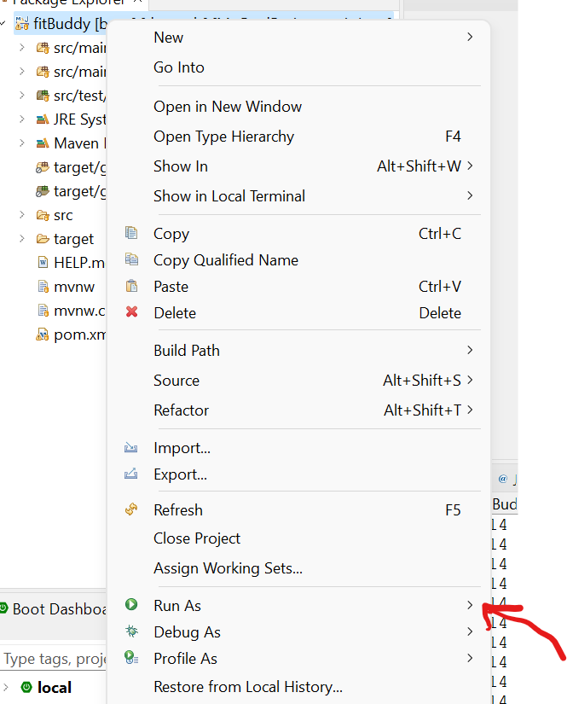

* Click on **Run as>** and it’ll open a list of new options:

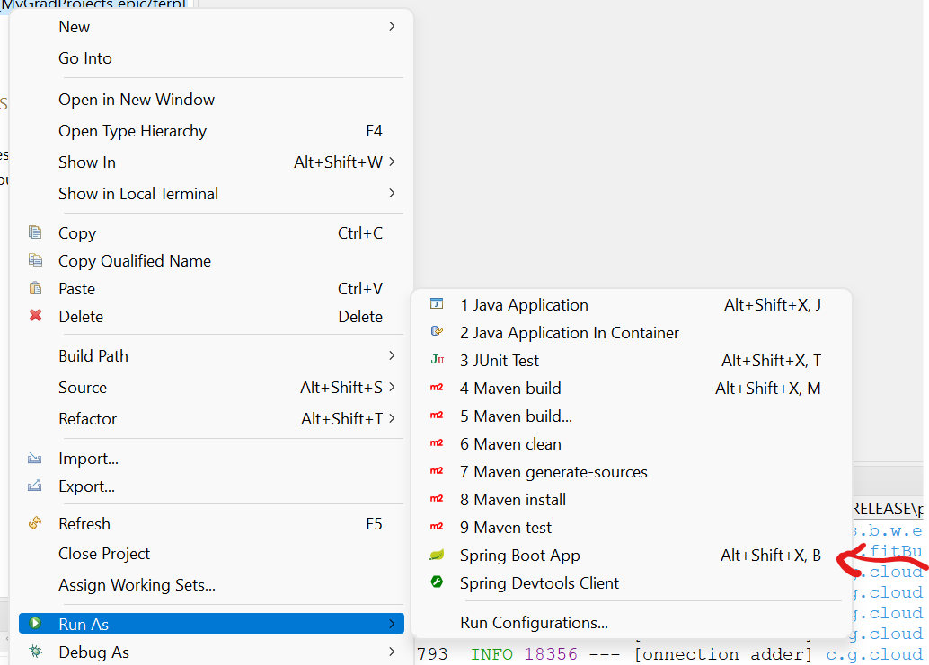

* Then click on **Spring Boot App.** This will start the application.
* And you’ll be able to see the app is running on port:8080 without any errors.

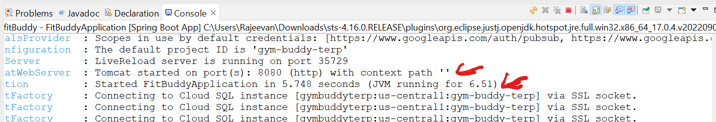

* **In case there are any errors while running**, Please go to a project Clean.(**Project > clean** )
* Then go back to Run As by right clicking the project and do Maven Install. **(Run As > Maven Install ).** (Note: This might give you error saying unit test cases failed. Since we have to start on unit testing cases from next week.)
* Then go ahead and try running the project again following the same instructions as before.

Now that you have UI and Backend up, you can open localhost:4200 and see the app running.

Since we need the DB running all the time, we created a project in Google cloud services so that it’ll be up and running instead of being in a local machine. And this integration is done between Back-end and Cloud SQL. So, thankfully, you don’t have to worry about bringing up the db in your local Machine.

Here is a screenshot of our app in google cloud services:-

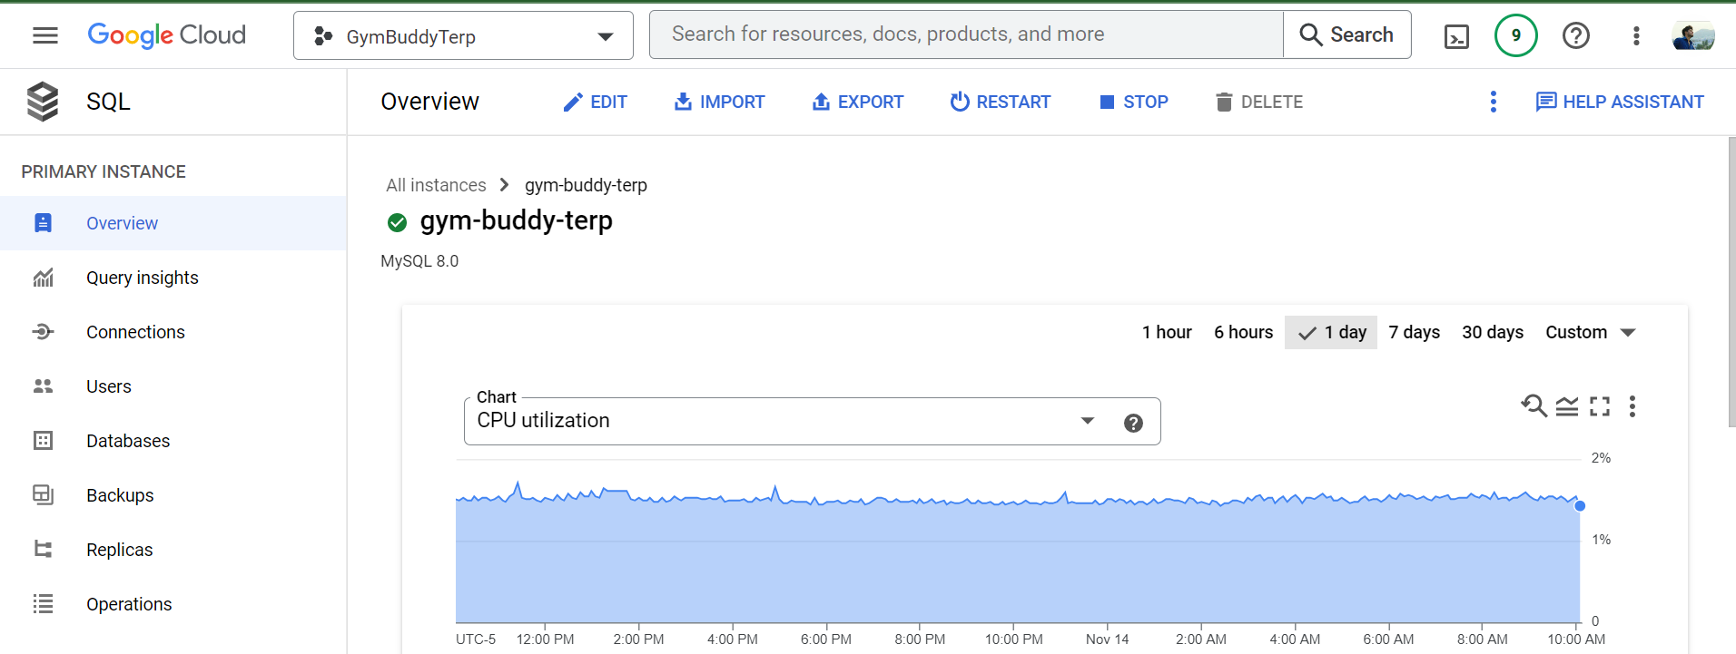

We had to learn a little bit about google cloud for this and a few other functionalities that we have in the app which was just pain! And trying to integrate all these services to our app was a nightmare. However, it was totally worth it. Got to learn a lot of new things to create the app and make it actually running. It was a lot of fun!